MISSION REPORT

Tempus SIGMUS team visited University of Udine and University of Maribor from 02 to 11 June, 2011. The Study Visit (SV) team, lead by Professor Vera Markovic, the contact person of the University of Niš which is responsible for the Working Package 1, was consisted of 8 members. Selected participants, beside Prof. Vera Markovic, were:
- Professor Radojka Krneta, University of Kragujevac, staff representative,
- Ivan Milošević, The Assoc. of Directors of Serbian Schools of Applied Studies, staff representative,
- Slavko Alčaković, Singidunum University, staff representative,
- Marko Grujoski, Megatrend University, student representative,
- Elvedin Halković, University of Novi Pazar, student representative,
- Vladimir Antonijević, Students’ Conference of Serbian Universities, student representative,
- Nevena Vuksanović, Students’ union of Serbia, student representative.

This visit was organized within the scope of the Work Package one (WP1) of the SIGMUS project: “Evaluation of student participation in the university governance and management and student services in the consortium members”. The aim of visits was to be acquainted with the experience and best practice related to the student involvement in University governance bodies and to acquire useful information about organizing the student’ services. A broader objective of visits was building links for further interaction and cooperation between partner institutions.
Before going to Italy and Slovenia, the Study Visit Team had several online, preparatory discussions. The SV Team was in Udine from 2nd until 8th of June and in Maribor from 8th until 11th of June, meeting different stakeholders of the higher education and student’s organizing. In Udine, the working language was English, in Maribor, both Slovenian and Serbian.
Between the meetings, the Study Visit Team had time for cultural and social activities.

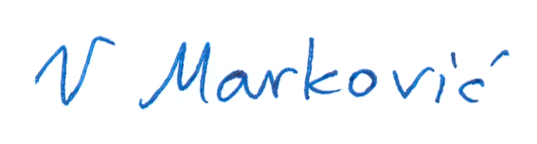
Prof. Vera Markovic,
Contact person of the University of Nis, Serbia

